Go to Magnolia ISD website: http://www.magnoliaisd.org/
Click on tab that says For Students and Parents.
Scroll down to HAC – Home Access Center and click on it.
You will be redirected to the page below. From this page click on the link that says HAC Login and Registration on the right side of the screen.
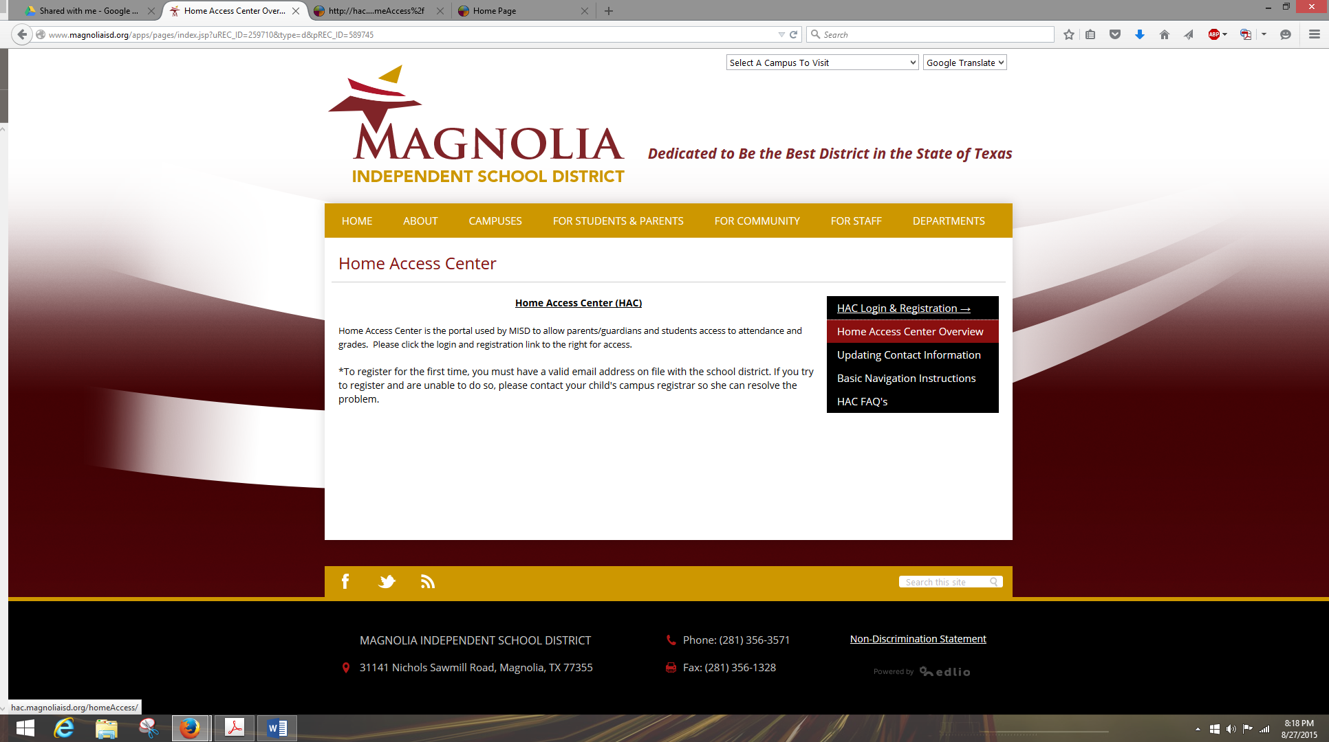
Once you click on HAC login and registration, you will be redirected to this page.
